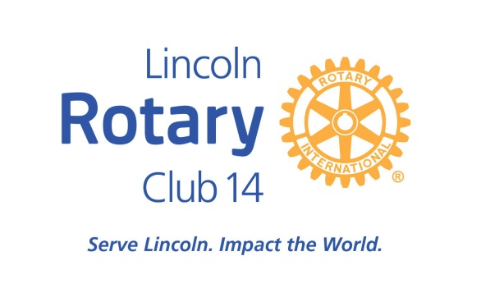

LINCOLN ROTARY CLUB #14 FOUNDATION COMMUNITY GRANTS
Guidelines for Application

The Object of Rotary is to encourage and foster the ideal of service as a basis of worthy enterprise. To that end, funds are raised by members of Lincoln Rotary Club #14 and granted to eligible organizations by the Lincoln Rotary Club #14 Foundation.

The Lincoln Rotary Club #14 Foundation supports a broad range of activities. Our current top community priorities are children & youth and education
& literacy. Other areas which may be considered, if funding is available, are hunger & shelter; health, disease prevention & water quality; economics & community development; ethics; environmental conservation & education; arts
& culture; senior services and human diversity & resettlement.

Community Grants are made primarily in Lincoln/Lancaster County. Grant amounts range from $250 - $5,000. Priority is given to specific projects over general operating requests.

Priority will be given to organizations that have not received funding from Rotary in the past two years.

The following areas are not eligible for grant review: individuals; businesses; churches or religious organizations; endowments; non-501(c)(3) organizations; scholarships and fellowships; program advertising or sponsorships or political organizations.

Applicants generally should be organizations described in Section 501(c)(3) of the Internal Revenue Code and have a written ruling from the IRS that they also qualify under Section 509(a)(1), (2), or (3) of the Code (publicly supported organizations and their affiliates).

There are two grant cycles each year. The deadlines for application are February 15 and August 15. Applicant organizations can expect to learn the outcome of their request approximately 90 days after the deadline. Please note that a brief report of how funds were used may be required by grant recipients.

Applications should be submitted electronically as indicated on the application form. Please provide the information in the order in which it is requested.

If electronic submission is not possible, please contact Rotary Club #14, P.O. Box 83843, Lincoln, NE 68501 for an alternative submittal option.

LINCOLN ROTARY CLUB #14 FOUNDATION
COMMUNITY GRANTS
Application Form

Date:

Organization Name: Address: Federal Employer Identification Number: Telephone Number: Fax Number: Email Address: Web Site: Chief Executive Officer: Contact Person and title (if other than CEO): _ Amount of request from Rotary Club #14: $_ Purpose of funding request (one paragraph summary):

Please attach a proposal narrative not to exceed three pages, providing the following information:
- A brief summary/overview of your organization including: Mission/Vision
The needs, problems or opportunities that your organization addresses
Current programs and services
Population served by your organization

- Information about your funding request including: How will the funds be used?
What is the intended outcome of this project? How does this project meet community needs? In what way, if any, is this a new effort?
If applicable, what other organizations are collaborating on this project? What are your other sources of funds, if any, for this project?
What is the timeline for implementation? How will this project be funded in the future?
Have you received funding from Rotary Club #14 in the past? If so, when and for what?

Please submit the following supporting materials:
- Audited financial statement for the most recently completed fiscal year. If your statements are not audited, indicate why and submit your income and expense statement for the most recently completed fiscal year.
- The most recent IRS letter confirming your organization’s tax exempt status.
- A list of the members of your governing board.
Email an electronic copy of the Application Form and the required supporting information to Rotary Club #14 Community Grants, Lincoln14Foundation@Rotary14.org. Either Word or PDF files are accepted. If you are unable to provide any required documents and attachments electronically please contact us.
Please do not submit additional materials (articles, brochures, testimonials, etc.)

